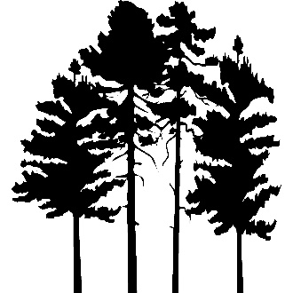
BCCA NEWSLETTER
September 2025

Please send all written correspondence to:
bristolcourt@nsmanagement.net or office@bristolcourt.org

Board of Directors
All owners are invited to the Board of Directors' monthly meeting held in the
party room of 2500 Windsor Mall on September 30th at 6:30 p.m.

BCCA Election Results
- Congratulations to the re-elected Board members for a two-year term:
Anne-Marie Adams, John Ciprian, Fran Dellar, and Sharon Smith
- The Board welcomes new members:
Mike Butler and Jackie Tsevis
- Serving the Board for another year:
Bill Nelles, Steve Kuhn, Lenore McCann, Natalie Lyubashenkok, Elaine Paterakis, and Danuta Winogradzki
- Thank you for serving to:
Lou Gianetti, Maureen Moore, John Vogelsberg, and Peter Wachowski

Halloween Information
- Lobby Halloween/Fall decorations may be put up starting Oct.1st and taken down by Nov.9th. Fall decorations may remain.
- Decorations should be cheerful rather than scary
- Trick–or–Treating will be held on Sunday, October 26th from 2–4 p.m. in the lobby areas or under the canopies of participating buildings.
- Resident volunteers from each building are encouraged to hand out wrapped store-bought treats that residents of that building have donated.
- Resident children, 12 and under, are encouraged to dress up and visit each building that has a pumpkin balloon in front of it.
- Children are to be accompanied by a parent. (Parents are welcome to dress up, too.)

New Vehicle Parking Stickers
- Beginning Monday, September 8, 2025, all vehicles parked at Bristol Court must display the new WHITE parking sticker.
- Vehicles without the new sticker will be considered in violation of the Association rules.
- To receive a new sticker, go to the office with a copy of the current vehicle registration for each vehicle being registered in the name of the current resident.
- Place the sticker on the driver’s side rear window.

Federal Pacific Electric Panel Replacement
- Thank you to all the owners who completed the Federal Pacific Electric panel replacement project on time.

